Move and stay active with other kids and families across Dane County with Healthy Kids Collaborative’s new physical activity, health, & wellness show and WIN PRIZES!

Watch the Show; Be Active and Win Fabulous Prizes. Details on Page 2&3.

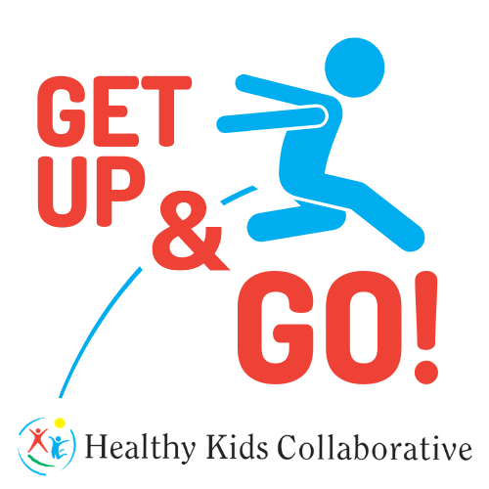
Research shows Kids need One Hour of physical activity each day…

Physical inactivity contributes to heart disease and type 2 diabetes.

The more you move, the more you win!
For more Info contact Shawn Koval, Healthy Schools Coordinator: skoval@uwhealth.org

Get Up & GO!
Kids Contest

Get Up & Go! encourages Dane County students like you to be physically active during virtual learning. Our Kids Contest is designed to celebrate your success by awarding prizes to frequent viewers/movers. We hope the contest motivates you to stay moving and keep practicing the healthy habits we share on the show.
Prizes will be based on the point reward system:

Level 1: 50 points (5 episodes) (prize entries accepted until Friday, December 11th, 2020)
Level 2: 100 points (10 episodes) (prize entries accepted until Friday, December 11th, 2020)
Level 3: Video submission for the Grand Finale (prize entries accepted until Tuesday, December 15th; final episode to air on December 17th, 2020)

Rules:
- After viewing each episode, go complete the student response and feedback form via Google Docs to share with us how the activities went for you. Earn 10 points for each form you complete.
- Winners will be notified via e-mail by the Get Up & Go! to choose their prize.
- After earning a Level 1 prize, students can start working towards a Level 2 prize. A student can win both level 1 and 2 prizes and can submit a video to win level 3 prizes.
- The student who don’t complete level 1 and 2 can still participate to win a level 3 prize.
How to enter to win a level 3 prize:

- Talk to your parents/guardians and get permission to participate in the Get Up & Go! Grand Finale video contest.
- Ask your parents/guardians to help you complete and sign the “Photo Release Form” from the SeeSaw activity page or Healthy Kids Collaborative’s website.
- Film yourself doing part or all of a Get Up & Go! episode. Follow Mr. Shawn’s examples from the other episodes or do it in a style all your own – it’s up to you! Video submissions will be accepted in the following categories, which are based on the Get Up & Go episodes with Mr. Shawn:

Categories | Duration of the video
Opening Activity: Got Water? Reminder + Power Pose | 3 mins or less
Warm-Up Activity (example: stretching routine) | 3 mins or less
Main Physical Activity (examples: fitness work out, movement story) | 5 minutes
Healthy Snack of the Day & Give Me 5 Dance or Song | 3 mins or less
Closing Activity: Body-mind reflection or calming routine (example: mindful breathing) | 3 mins or less

- Send the video to your class teacher thru SeeSaw or to Mr. Shawn at skoval@uwhealth.org.
- The best video in each category will receive a level 3 prize. You can participate in all five categories to increase your chances of winning.
- The Grand Finale episode will feature all five winning videos.
- The deadline to submit a video and photo release form is December 15, 2020.

*Prize List:
Level 1 | Level 2 | Level 3
- Pedometer (Step Counter) (New Lifestyle Brand – Yamax Digiwalker model)  - PE at Home Equipment Kit (Gopher Brand)  - Bicycle equipment pack: helmet, lights, lock  - Wisconsin State Parks vehicle admission sticker  - $25 Gift Cards:  - Dick’s Sporting Goods  - Play It Again! Sports  - Local swimming, tennis, soccer or other sports store of your choice | - Family Fun & Games Box!  - Indoor edition w/ activities like board games, books & more.  - Outdoor edition w/ snow/winter themed equipment.  - Aldo Leopold Nature Center family membership  - Swim Passes for you & your family at a place of your choice (Goldfish Swim School, Swim West, YMCA, etc.)  - Tennis Classes at Nielson or John Powless  - $50 gift cards:  - Boulders Climbing Gym  - Madison Ice Arena  - Vitense Golf Land  - Fast Forward Skating Center  - Tyrol Basin  - Swimming or Tennis Center of your choice!  - Sky Zone Trampoline Park  - Urban Air Adventure Park | - RollerBlade (brand) Roller Blades  - Ice Skates  - Snowshoes  - Used but- Like-New Bicycle  - Wrist-Style Fitness Tracker  - $100 Gift Cards:  - Boulders Climbing Gym  - Madison Ice Arena  - Vitense Golf Land  - Fast Forward Skating Center  - Tyrol Basin  - Swimming or Tennis Center of your choice!  - SkyZone Trampoline Park  - Urban Air Adventure Park  - Sports Equipment store of your choice, like Dick’s, Play It again, local swimming, tennis, soccer or other sports store of your choice
*Prizes are subject to the availability of grant funds. Healthy Kids Collaborative reserves the right to change terms and conditions without notice.

